1. Palindrome String Check.
2. Replace vowels in a String with ‘#’.
3. Finding the min and max value in a given array.
4. Check if an array contains a particular value.
5. Find average value of array elements.
6. Reversing the words in a sentence.
7. Finding common elements between 2 integer arrays.
8. Add two 3X3 matrices and print the resulting matrix.
9. Sorting an array (try bubble sort and explore how it works).
10. Reverse a sequence of numbers in an array without using an additional variable and additional array.
11. Explore Armstrong number and write a program to find Armstrong numbers < 1000.
12. Given an integer , find out the total of its individual digits.(e.g. 8904 = 8+9+0+4 = 21).
13. Find the smallest difference between two neighbor elements in an integer array.( In the sequence 4 8 6 1 2 9 4 the minimum distance is 1 (between 1 and 2), also print both the numbers).
14. In a 3X3 array, print the average of numbers in the upper right triangle.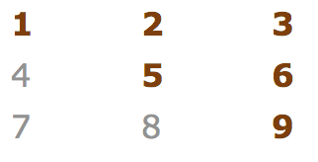
15. Take 2 arrays as input and give 3rd array which will have elements from both the arrays. If there are common elements they should only appear once in the final array.
16. Take an array as input and reverse the values of its elements. (eg 134 should become 431 and 110 should become 011).
17. Find out all the prime numbers under 100.